# Oddle Backend Challenge - V2

A simple weather checking API service

1. Database

* MySQL 5.7.37 (MySQL supports the native JSON data type since version 5.7.8).

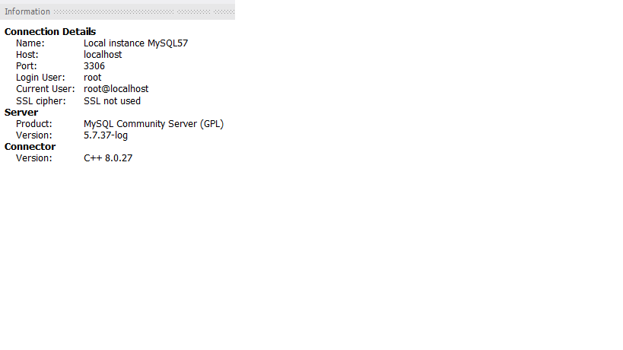

* Execute the weather.sql attached in folder database

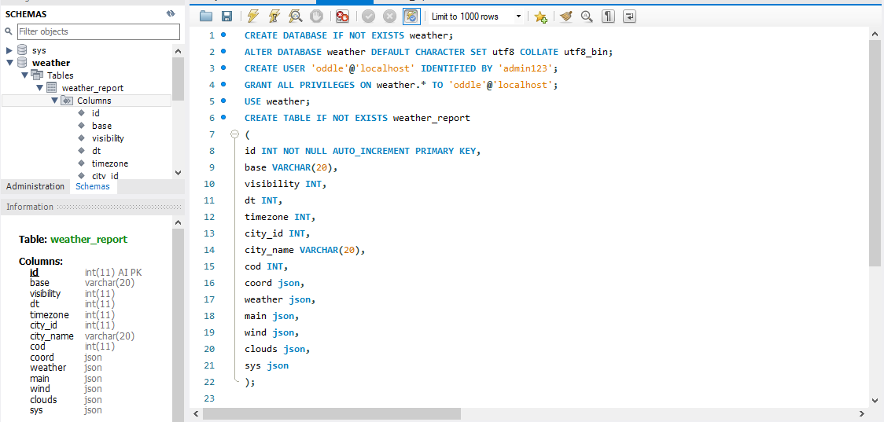

1. Source code

* Addition dependencies:

implementation group: 'com.vladmihalcea', name: 'hibernate-types-52', version: '1.0.0' - (Mapping the Java entity to JSON column)

implementation group: 'io.springfox', name: 'springfox-swagger2', version: '2.9.2'   
implementation group: 'io.springfox', name: 'springfox-swagger-ui', version: '2.9.2'

(To document APIs)

* All the tests passed

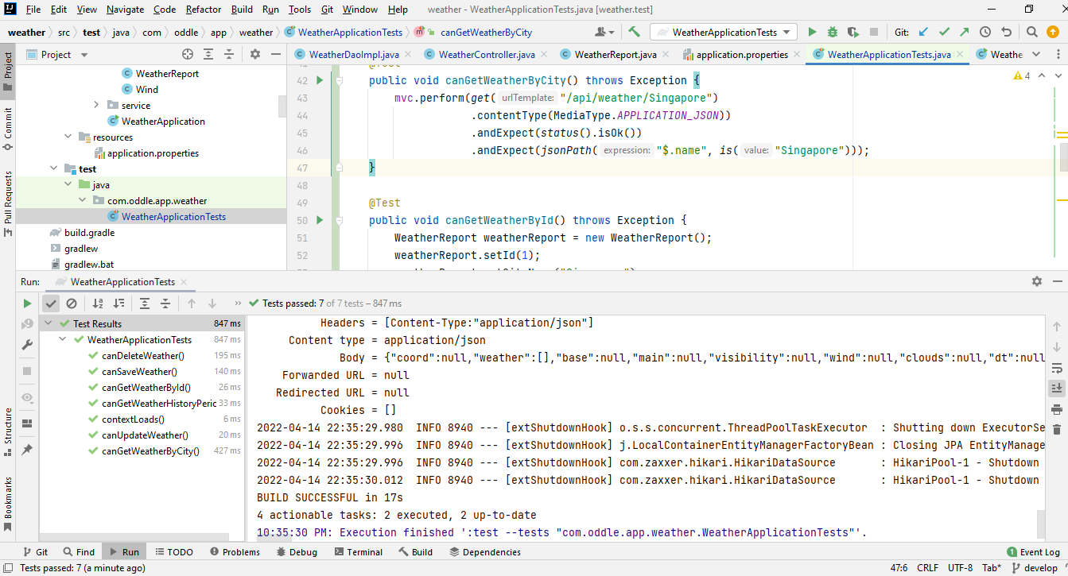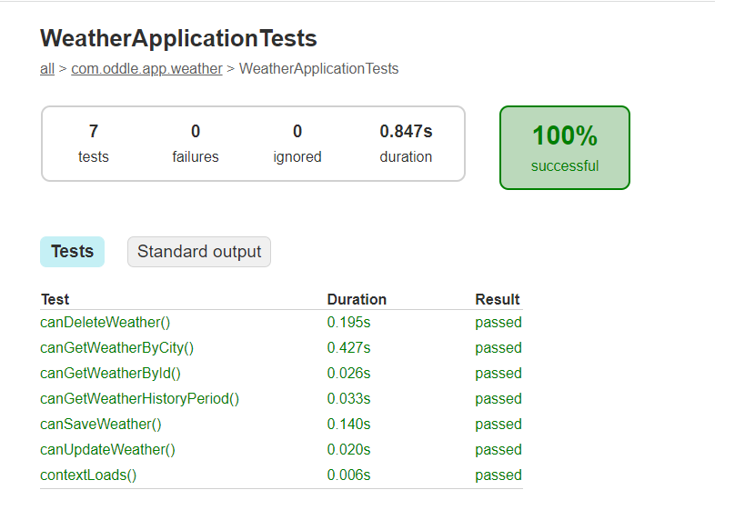

1. Document

* Access swagger: <http://localhost:8080/swagger-ui.html#/>

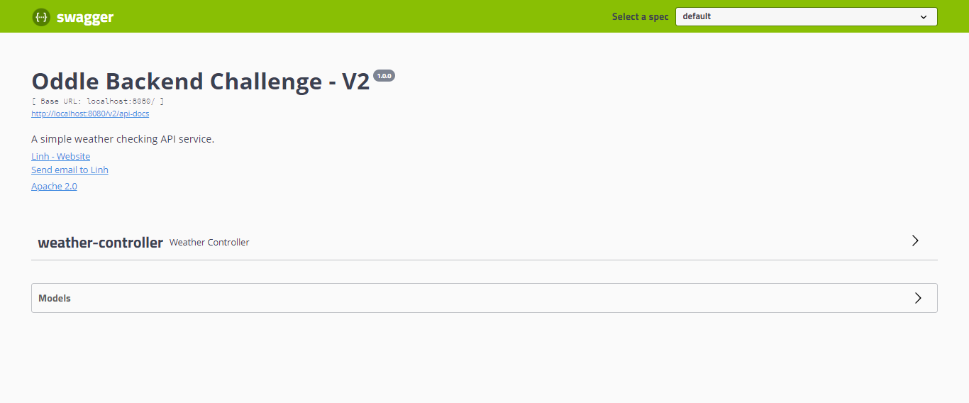

* APIs detail

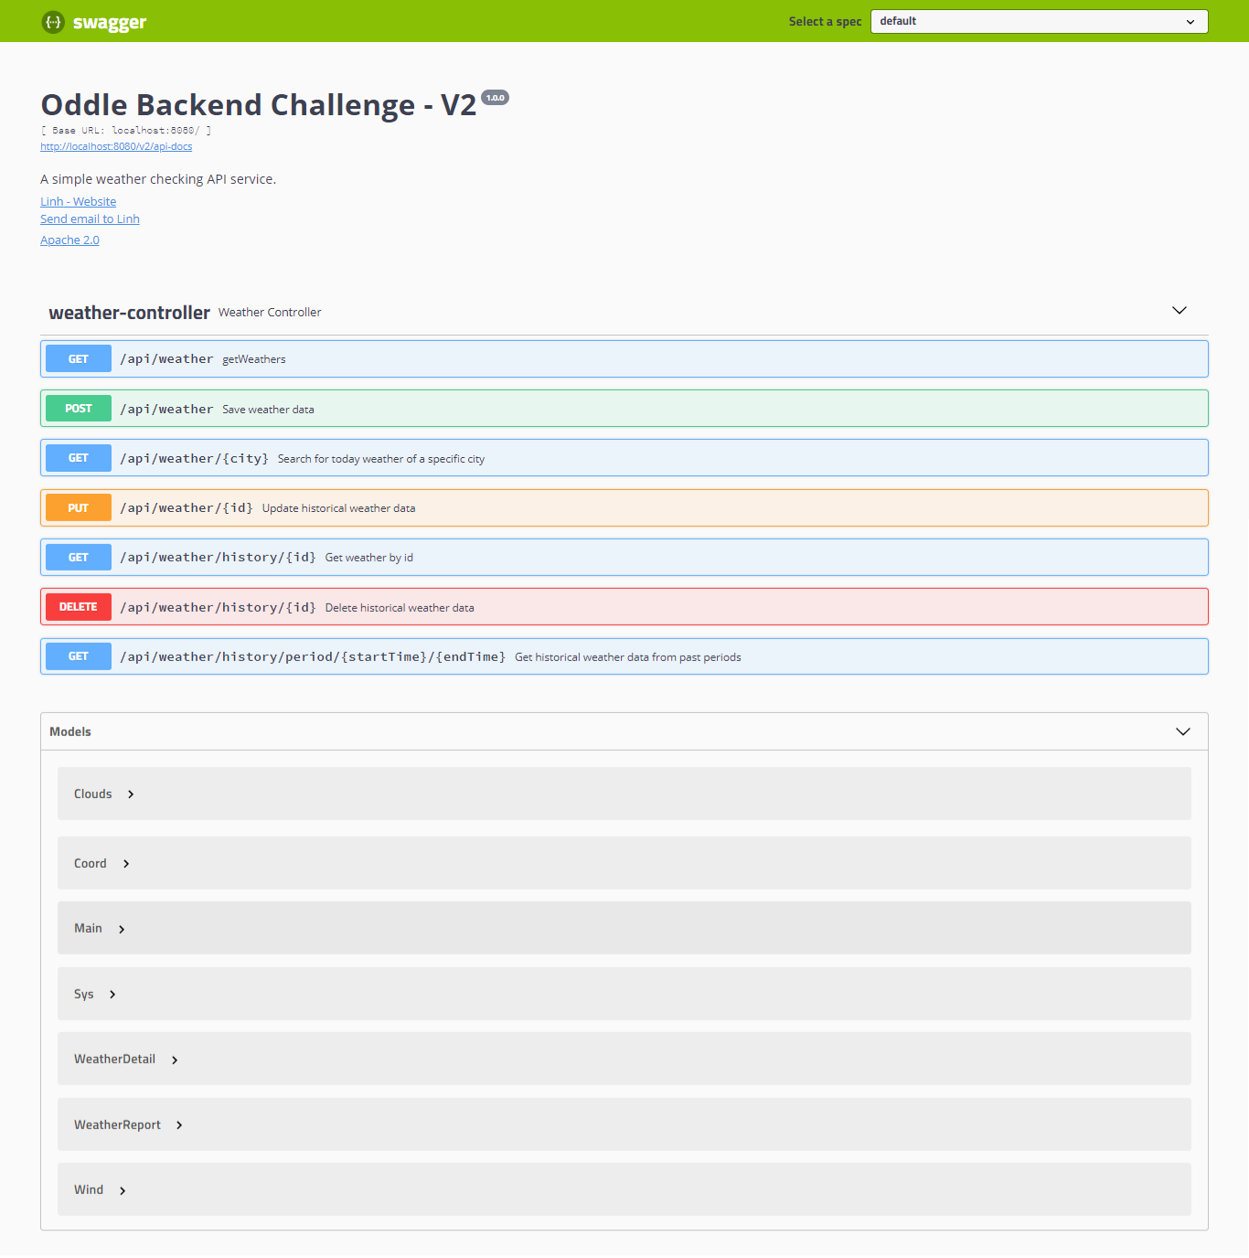

* Let’s try it out the APIs.

**GET weather by city**

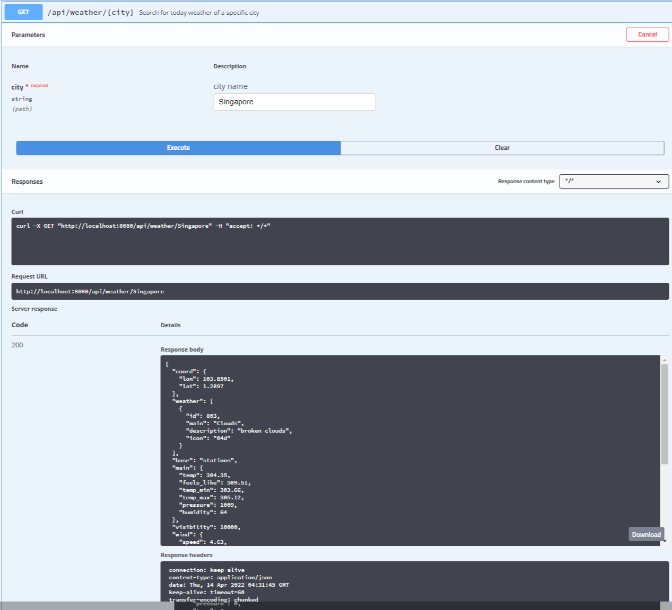

**POST to save weather data (can use the response body from GET to input the POST request body and execute)**

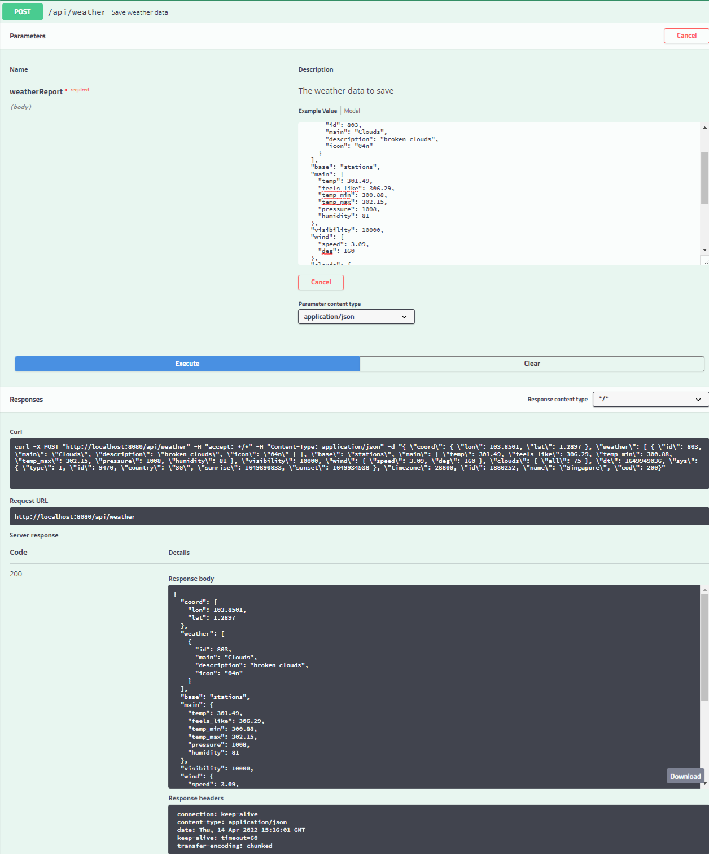

**It saves weather data to database**

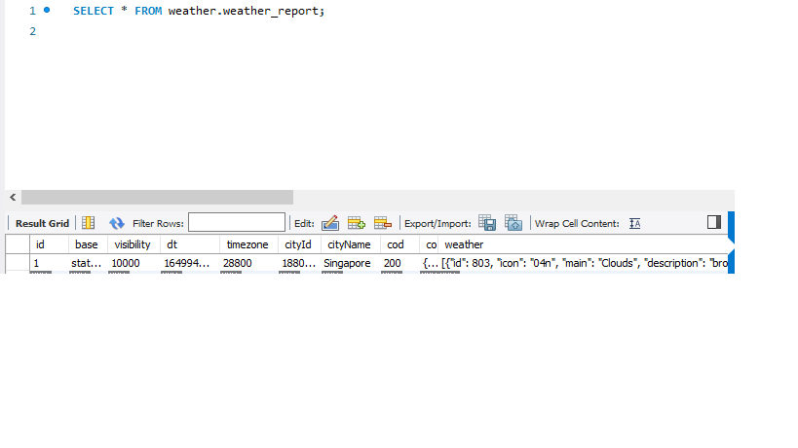

**Get history weather data from past period**

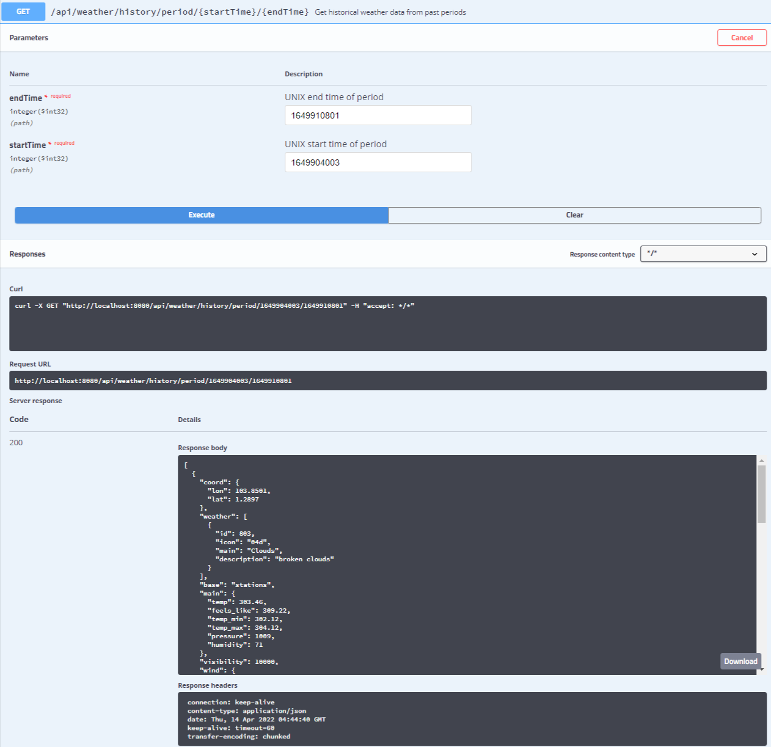

**Update history weather data**

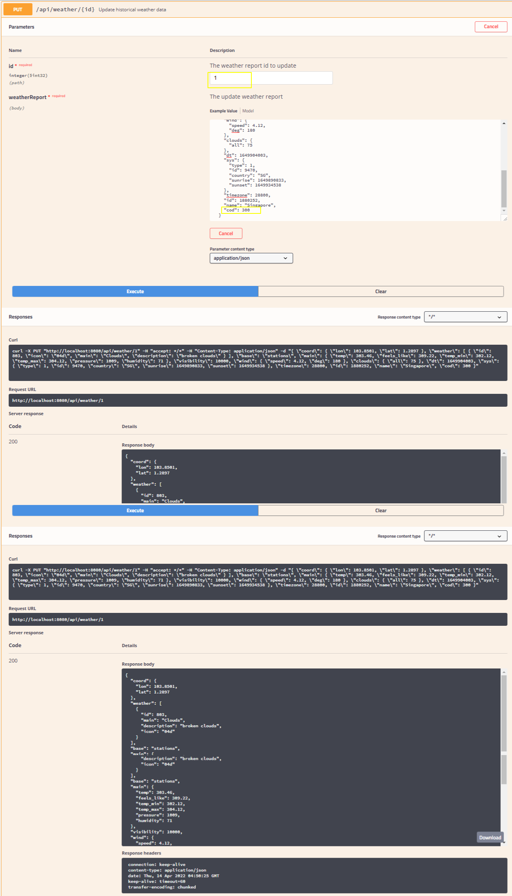

**It updates the record in database**

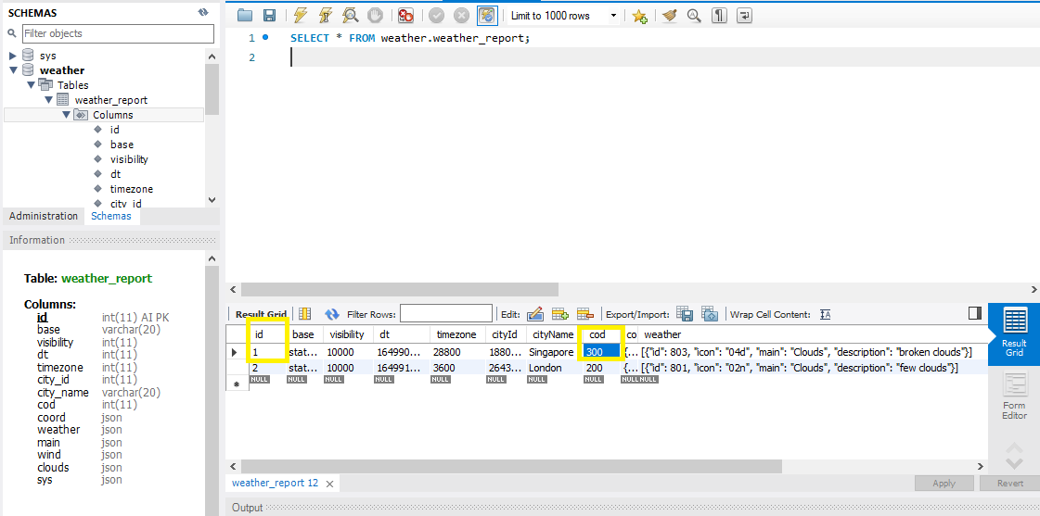

**Delete history weather data**

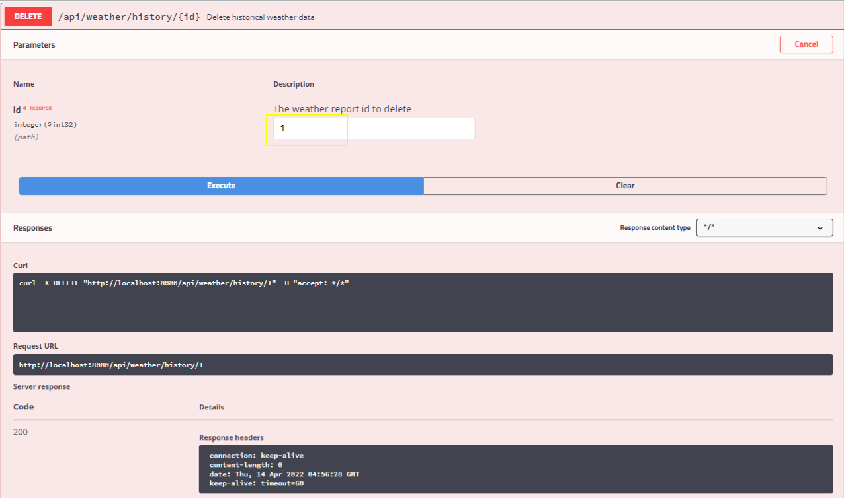

**THANK YOU FOR READING!**